DATE: 28.12.2018
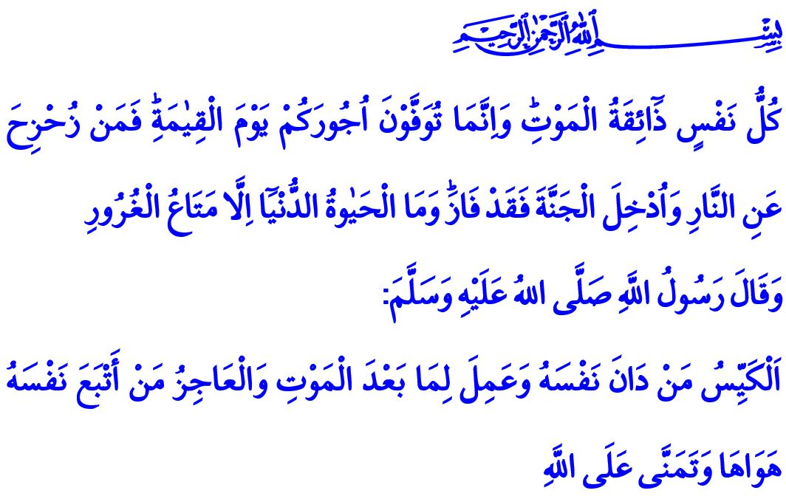
LIVING A LIFE WITH
THE AWARENESS OF RESPONSIBILITY
Honorable Muslims!
In the verse that I recited, Our Sublime Lord declares that: “Every soul will taste death, and you will only be given your [full] compensation on the Day of Resurrection. So, he who is drawn away from the Fire and admitted to Paradise has attained [his desire]. And what is the life of this world except the enjoyment of delusion.”
In the honorable hadith that I read Our Dear Prophet (s.a.w.) says: “The clever person is the one who subjugates his soul and works for what is after death. And the incapable is the one who follows his desires and merely hopes in Allah.”
Esteemed Believers!
Our Lord created death and life to test us [as to] which of us is best in deed. In the eternal world, what will turn into good news of heaven or torment of hell is what we have done during this line of life, or what we have neglected and abandoned. We all see that we live by the time that flows like water and every day we are running out of our life capital. Every minute passes us away from our youth and brings us one step closer to maturity and even old age. We're moving towards the day of our death and judgement that we do not know when, where and how we are going to face, inevitable ending.
Valuable Muslims!
Our Sublime Lord in The Holy Qur’an, declares that, “Does man think that he will be left neglected?”. This verse warns us that all the blessings of our Lord, especially life, also require responsibility. Like all the blessings that we are incapable to give their due thanks, our life is a trust to us from Our Lord. So, we are responsible for where and for what we spend our life. In the words of Our Beloved Prophet (s.a.w.), there are two blessings which many people lose: (They are) Health and free time for doing good. Yet, the times spent with the awareness of responsibility towards Allah turn into earnings and save the owner from the frustration. Those lives are blessed which believing Allah and abiding by the Sunnah, the life of the Messenger of Allah. The lives adorned with goodness, beneficence, virtue and beautiful morality, flourishes.
Valuable Believers!
We are leaving behind another year of our life, where we are sent to develop a peaceful and just world that is appropriate to our Lord's contentment. These days in which the calendars are changed are an important opportunity for us to account for the past. To review our mistakes, to repent to our sins, to make new and correct decisions, to open immaculate pages of our lives, it is a rare opportunity. Otherwise, the new year is not a time period for forgetting our religious and moral values and displaying behaviors that are incompatible with our national and spiritual sensibilities.
Esteemed Believers!
Let us ask ourselves as we enter a new year based on Christian calendar: Are we able to place the faith and determination to win our contentment of Our Lord in the center of our lives? Or did we go after our desires? Did we spend our power and strength, our knowledge and labor, our mind and our experience for the sake of exalting Islamic values, human and moral values? Or did we prioritize our daily desires and personal expectations? In our heart, have we included mercy, justice, humility and wisdom? Or have we succumbed to arrogance, stinginess, envy and showing off and pretending to do good actions, without having the real intention for doing it? Did we connect faithfully to the divine edict of Our Lord? “O you who have believed, indeed, intoxicants, gambling, [sacrificing on] stone alters [to other than Allah], and divining arrows are but defilement from the work of Satan, so avoid it that you may be successful.” Did we get our hands-off evil? Do we keep our tongue away from sinister words? Did we clear our mind of bad thoughts? Did we fill our heart with the love of Allah? Have we been able to protect the rights of our parents, our spouse, our children? When was the last time we caress an orphan's head? Which of our neighbors did we ask about their wellbeing? Which elderly heart we conciliated? Which poor person's need did we eliminate?
Valuable Muslims!
Let's decide to equip our remaining life with good and beautiful deeds that will earn our Lord's contentment. Let us not forget the honorable responsibility of being a human, the weight of shouldering the trust of Allah and the proximity of the day of the judgement. Let's not waste our time. Let's stay away from null and useless jobs. Let's give up our mistakes and errors. Let's multiply our worship, good deeds and charity. Then every year of our life will become a true milestone for us, a real possibility and hope.

Âl-i Imran, 3/185.
Tirmidhi, Description of the Day of Judgement, 25.
Mulk, 67/2.
Kıyâme, 75/36.
Bukhari, To make the Heart Tender, 1. 6 Mâide 5/90. General Directorate of Religious Services

